TANZANIA AGRICULTURAL EXPORT Perform 1998/99-2022/23
Overview of Agriculture Export Performance
Exports are crucial in the process of growth and expansion of the exports is an important part of economic growth process. Agriculture in Tanzania has been characterized by sustained growth over the years. But there has been slow growth rate in some of the crops such as sisal exports over the decade as it is shown in the graph
This report proposed to examine factors that influence agriculture exports performance from 1998 to 2023. Secondary data was collected from Bank of Tanzania.
The country implemented a number of reforms in order to reorient country’s economic policies towards an export-oriented growth strategy. These included establishments of the Export Processing Zones, joining Multilateral and Regional Trading blocs including the Southern African Development Community (SADC), the East African Community (EAC), the African Growth and Opportunity Act (AGOA), the World Trade Organization (WTO) and the Economic Partnership Agreements (EPA).
This was just to increase access to external market and promote export with the anticipation that investors in Tanzania will enjoy expanded market as well as preferential treatment for their products. The role of economic reforms and policies adopted in promoting Tanzania’s exports can be confirmed by the fact that total exports of some agriculture products in Tanzania have been increasing. This is as per the graph above which shows the trend of Tanzanian total export 1998-2023.
The model results showed that the real exchange rate, Agricultural GDP and foreign income had significantly influenced the Agricultural exports performance in the long run as it shows in cotton and coffee graph. Cashew nuts, coffee, tea, cloves have 20 percent share in Tanzania’s total exports as of 2020.
In spite of fluctuations, the value has overall increased in the last years. This was mainly due to Tanzania’s key role in the cross-border trade of staple foods in East Africa, supplying neighboring nations, like Uganda and Kenya.
Trends
The dataset includes annual agricultural export values for various commodities from 1998/99 to 2022/23. The main commodities analyzed are coffee, cotton, sisal, tea, tobacco, cashewnuts, and cloves. Each commodity's value, volume, and unit price are included
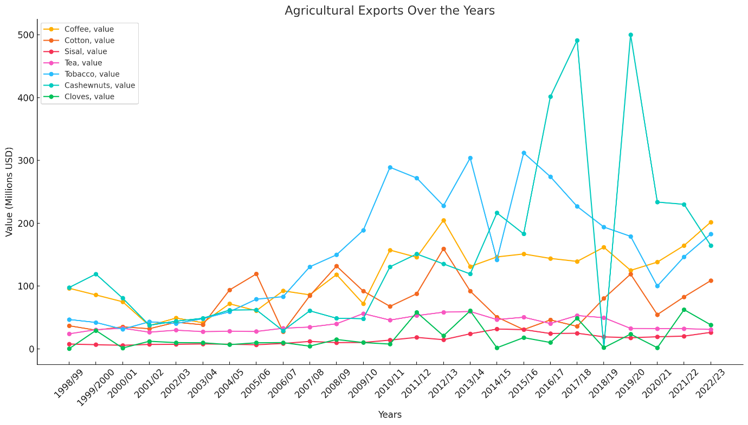
Data Source; BOT
The graph shows the trends in agricultural exports over the years for various products, including coffee, cotton, sisal, tea, tobacco, cashouts, and cloves. Coffee exports show a significant increase in the recent years, particularly peaking around 2021/22. Cotton exports fluctuated over the years, with noticeable peaks but not a consistent upward trend. Sisal exports have remained relatively low compared to other products but show some variations. Tea exports display a steady increase over the years, especially notable in the most recent years. Tobacco exports have experienced fluctuations, similar to cotton, without a clear upward or downward trend. Cashew nut exports show significant variability but have seen some growth recently. Clove exports are relatively low but have had occasional spikes, particularly in the earlier years.
​

Data Source; BOT
The chart reveals trends in pricing over time:
- Coffee: May exhibit peaks indicating significant increases in unit prices, particularly around certain years like 2011/12, possibly due to supply and demand dynamics.
- Cotton: Similar variability might be observed, reflecting fluctuating market conditions.
- Sisal and Tea: Their unit prices might show steadier trends compared to the other commodities, indicating more consistent pricing.

